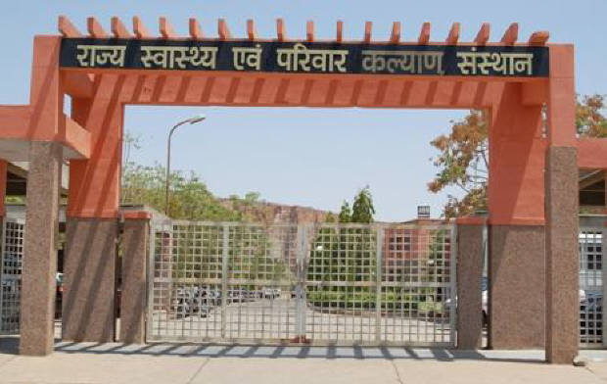
SIHFW Rajasthan

Electronic Newsletter
Ed. 2023 E-1 (Annual 2022- 2023) 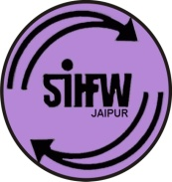
SIHFW: an ISO 9001:2015 certified Institution
From the Director’s desk…

Dear Friends…

Greetings from SIHFW!!

Present issue of newsletter brings latest training updates and important activites organized by SIHFW, Jaipur. The financial year 2022-23 started with remarkable pace of trainings and much larger quantum of trainings, which have never been in the past. Newest challenge of wide spectrum of HWC-Extended services trainings were introduced in the training scenario of Rajasthan, planned in 2023-23 and 2023-24 are being rolled out at State, zones and all districts.
We would solicit your feedback and suggestions.

Best Wishes!!
Dr. O.P. Thakan
Director-SIHFW
_____________________________________________________________
Some important health and social days for January to March 2023
January 1: World Day for Peace | March 1: Colorectal Cancer Awareness Month
January 27: World Leprosy Day | March 8: International Women’s Day
February 1-28: Healthy Lifestyle Awareness Month | March 13: World Sleep Day
February 4: World Cancer Day | March 20: International Day of Happiness
February 12: World Epilepsy Day | March 21: World Down Syndrome Day
February 15: International Childhood Cancer Day | March 22: World Water Day
February 24: World Sustainable Energy Day | March 23; World Meteriological Day
March 1-31: Tuberculosis (TB) Awareness Month | March 24: World Tuberculosis Day

Director Sir’s participation

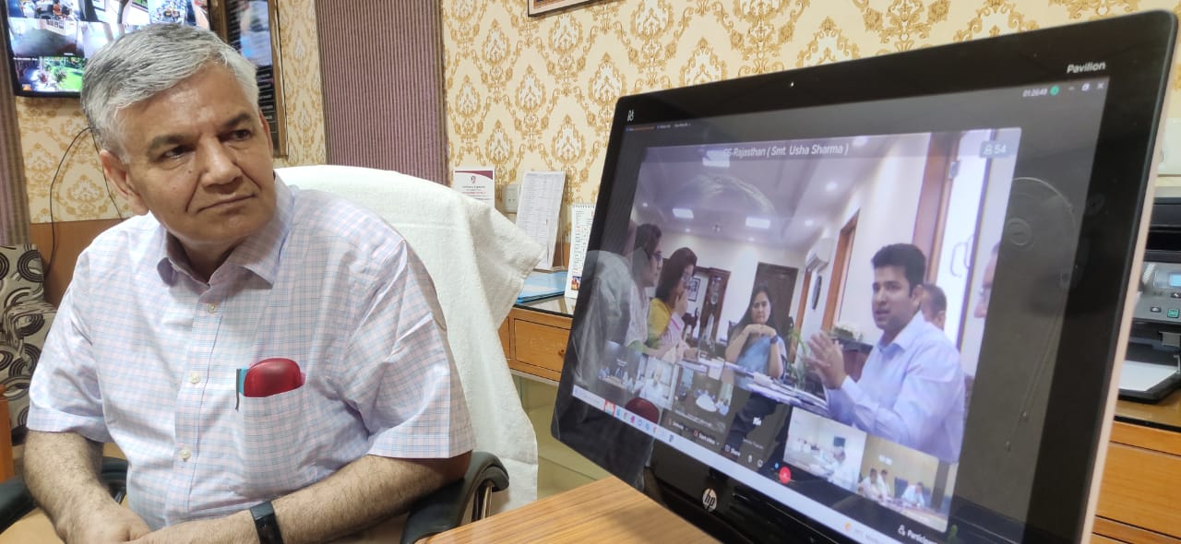
Director sir participated at State Level Video Conference to plan Rajasthan Diwas (March 30th, 2023), VC was held on 28.3.2023

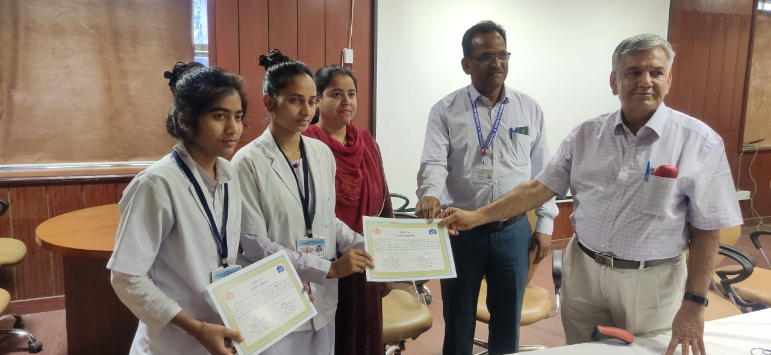

Director Sir awarded certificates to winners, first runner up and participation certificates to students of ANMTC and GNMTC at State level quiz competition on 28.3.2023

VC for Training review at SIHFW
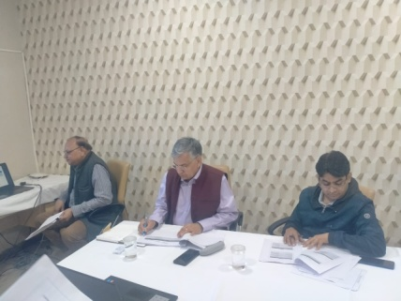
Online Video review meeting was organised under chairmanship of Director SIHFW on February 8, 2023. It was organised through google meet to review training progress under HWC trainings. Participants were CMHOs, Dy CMHOs (Health) and DPMU staff from all 34 districts. With an online presentation, all districts were briefed about set of trainings sanctioned in each district for various cadres-Medical Officer, CHO, Staff Nurse, ANM and ASHA. Physical and financial progress of HWC trainings was discussed with each district.

Another VC was organised on 24.3.2023 under chairmanship of Director, SIHFW to review progress under HWC trainings. CMHOs, Dy CMHOs (H), DPM, DAC, NCD coordinators etc from all 34 districts participated in these VCs.

Workshop at SIHFW

Workshop on World TB day

Under National Tuberculosis Eradication Programme, a one day workshop was organised at SIHFW on 25.3.2023.
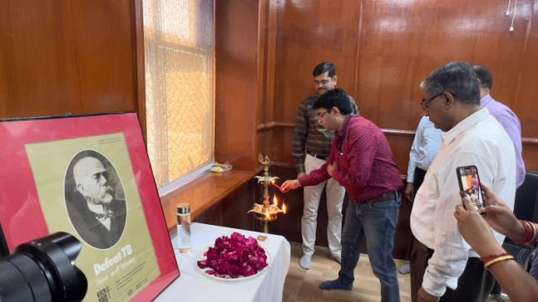

Workshop on PMSMA and EPMSMA

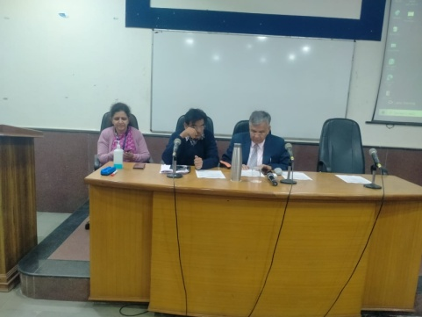
A workshop was organised for assessment of facility wise performance of government and private facilities. The best performer, Second and third awards were given to facilities. Workshop was organised at SIHFW on Feb 6, 2023

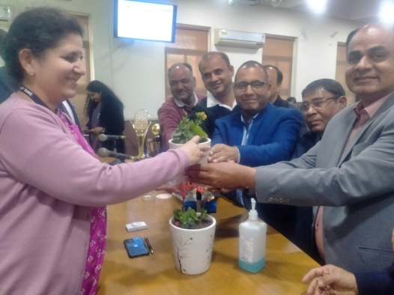
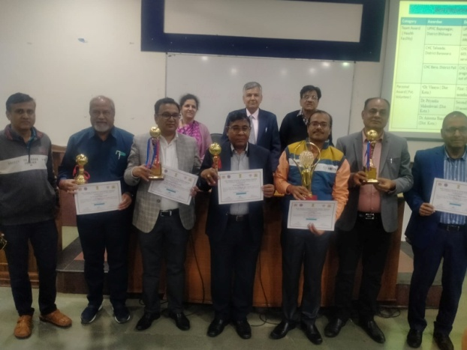

Workshop on Multisector Engagement with NTEP –TB Free Jaipur

One day workshop titled Workshop on Multisector Engagement with NTEP was organised by district team (DHS)-Jaipur at SIHFW on February 20, 2023.

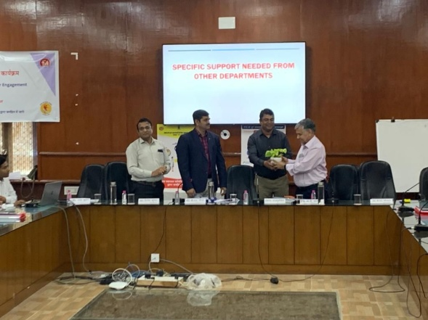
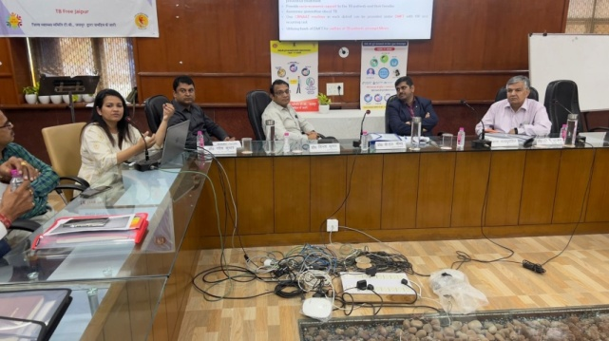

Workshop on Climate Change

Two days orientation workshop of Nodal Officers and Stakeholders was organised at SIHFW during March 28-29, 2023 under National Programme on Climate Change and Human Health.
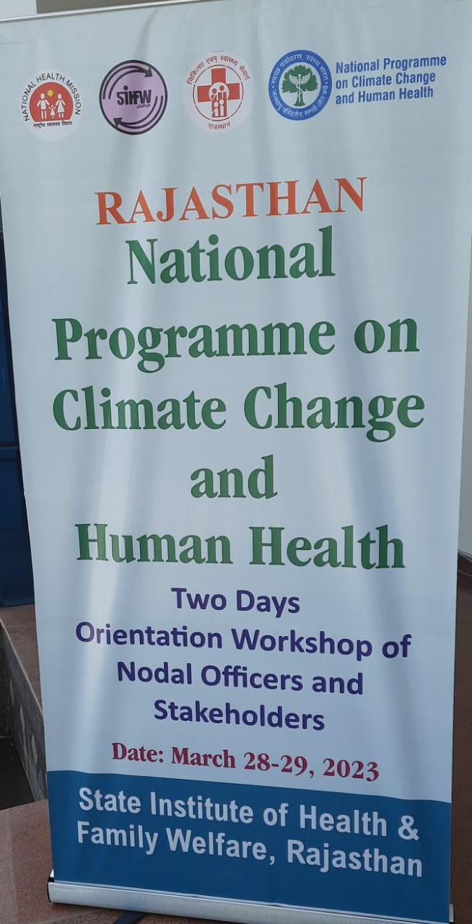

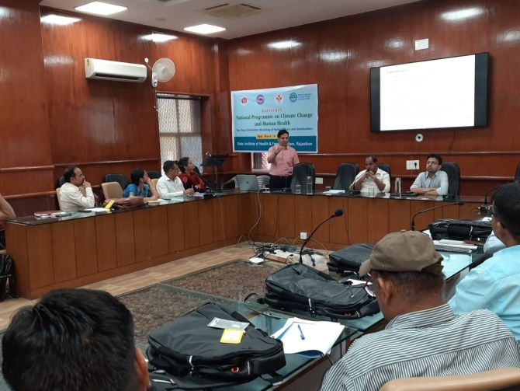

Workshop on MDR

A workshop to review Maternal Health, Maternal Death Surveilliance and Response was organised at SIHFW on 17.3.2023. Block Chief Medical Health Officers were sensitised in this workshop cum training.
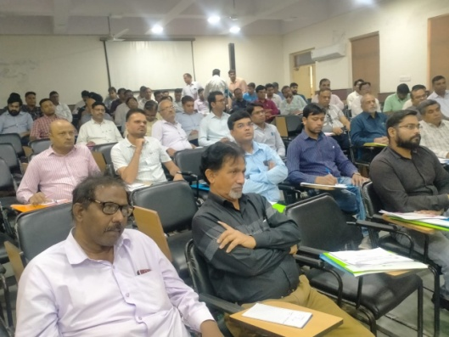

Trainings at SIHFW
Trainings on HWC-Extended Services
Extended Services under HWC includes 7 components-Mental and Neurological Substance Abuse (MNS), Elderly, Palliative, Oral, Eye, ENT and Emergency Services. All staff posted at Health and Wellness care centres –Medical Officers, CHO, Staff Nurse, ANM and ASHA under the HWC are being trained in above mentioned components. There are separate guidelines, duration, training objective and session plan for each cadre, depending on their roles and responsibilities at HWC.
ToTs on HWC-Extended Services
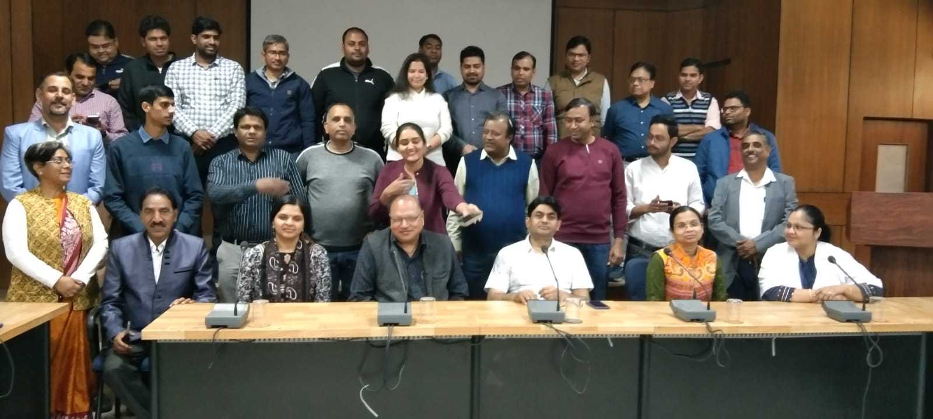
To implement the training to various staff, there is requirement of Trainers in all districts. Hence, 2 type of ToT were organized by SIHFW. Both type of ToT are of 12 days. ToT for Medical Officers is provided to only Doctors or Specialists such as Dental, Psychiatry, Anaesthesia, Medicine, Opthalmology, ENT, etc. Participants trained in this ToT become trainers for Medical Officers posted at HWC. This training is more focused on drugs, dosage, prescription guidelines, assessments, treatment protocols, management of emergencies and support to field staff of HWC.

ToT on MOs for HWC-extended services (12 days) organized at Forest Training Institute, Jaipur during January 30 to February 11, 2023
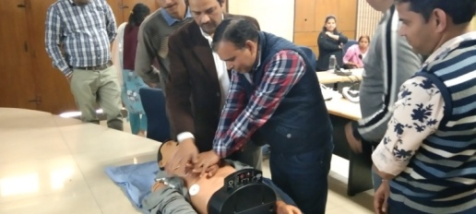
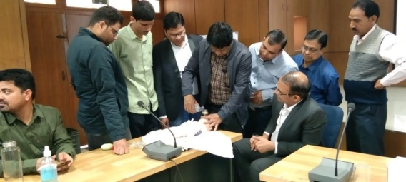

Hands-on practice sessions on management of emergencies at MOs ToT
The other ToT is for combined field staff-CHO, ANM, Staff Nurse and ASHA. Medical officers and Nursing Tutors, PHN participate in this ToT. This type of ToT is more focused on skills required for above components-such as- care of perenium, care of bed ridden patient, head wash, bed bath, how to prevent bed sores, oral hygine of conscious and un-conscious patients, naso gastric feeding, eye and ear drops, etc. Both the above ToT are organized at State level.
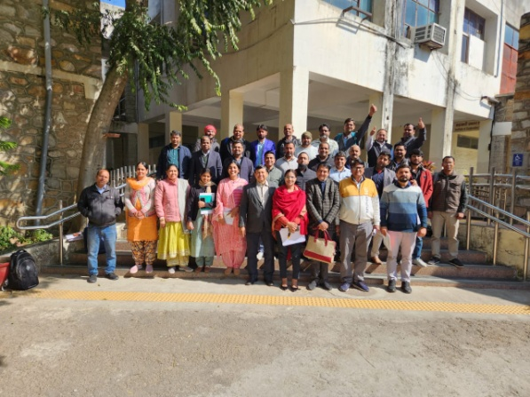
Group photograph of ToT on HWC-extended services for CHO and field functionaries (12 days), organized at RICEM Jaipur by SIHFW.
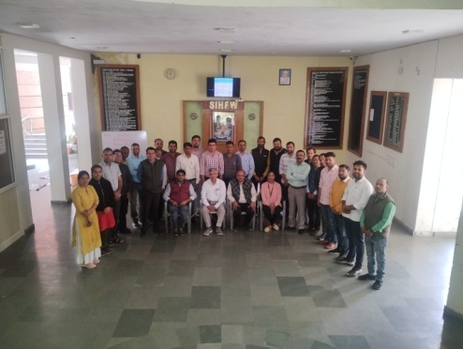
Another type of ToT is being organized at Zonal headquarters. This includes mix group of participants such as CHO, District ASHA Coordinators, etc and participants of these training become trainers for ANM and ASHA. ToT for Medical officers was also organized at all zones.
Traige Protocol Training
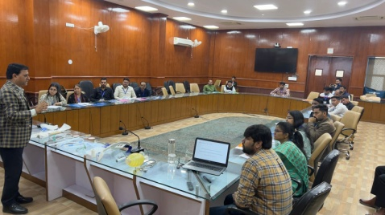
Training batches on Triage Protocol are being organized at SIHFW. This training is focused on strengthening Trauma and emergency care in Rajasthan. This training is supported jointly by Medical and Health services, government ofRajasthan and State Road Safety Cell, Transport and Road Safety Department. This is a 3 days training and organized at SIHFW .
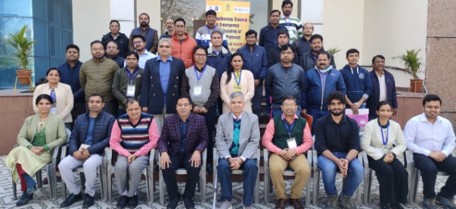
Photograh of Triage protocol training batch on Feb 13-14, 2023

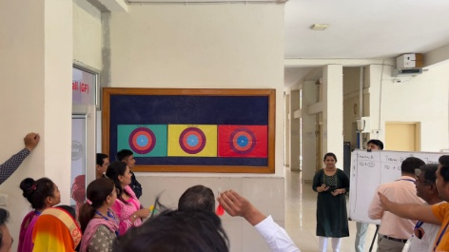
Interactive sessions and games for participants –at triage training
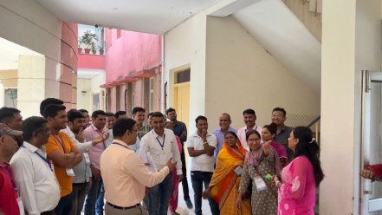

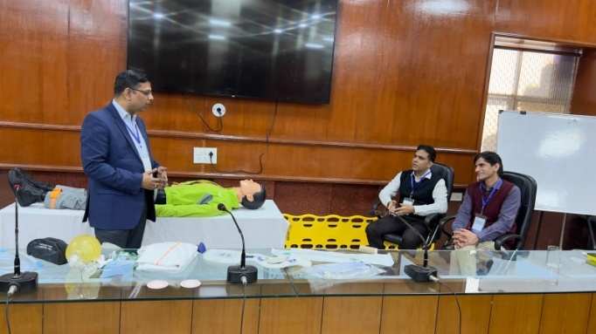

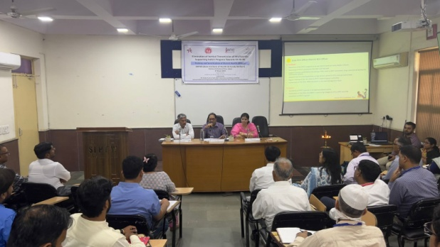
State level RCHOs & DPMs training on EVTHS
This was one day training organized on 27-3-2023 for Elimination of Vertical Transmission oh HIV/Syphilis, Supporting India’s Progress towards 95-95-95.

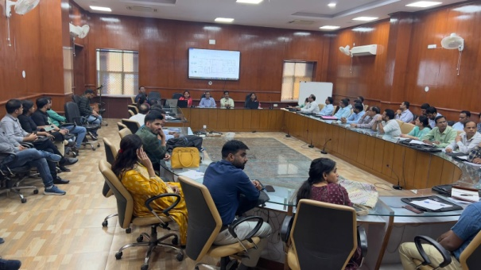
Meeting of State IDSP Cell
One day meeting of the staff under IDSP was organized at SIHFW on 27.3.2023 with objective to review on going works and plan for the interventions under IDSP in Rajasthan.

NTEP orientation training
Stakeholders were oriented on National Tuberculosis Eradication Programme at SIHFW on March 21, 2023.

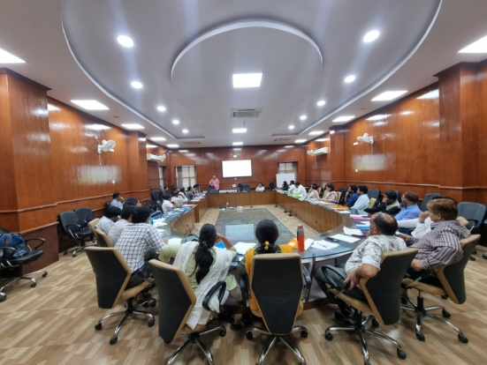
State level ToT for Routine Immunization for HW
2 batches of 2 days State ToT for Health Workers Routine Immunization were organized at SIHFW on March 13-14 and 20-21, 2023. After this training, participants became trainers for Health workers training on Routine Immunization. Participants included Medical Officers, PHN, Nursing Tutors and Nursing Officers.
ASHA ToT –Online and Offline
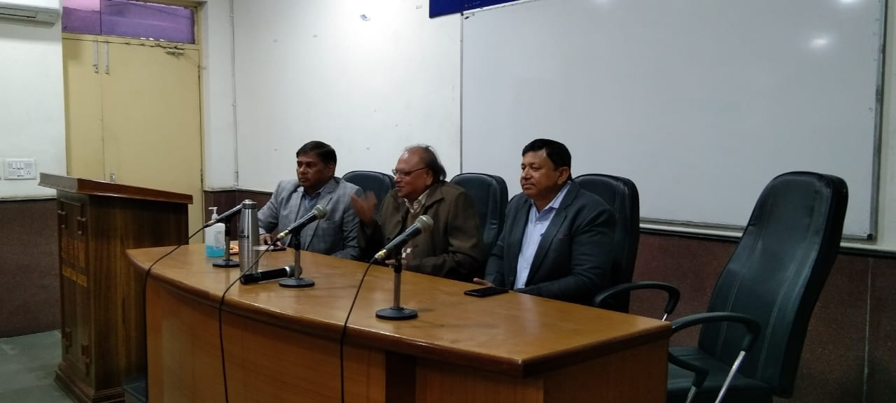
During January 5 to 23, 2023, ASHA ToT batch was organized by SIHFW. This is a hybrid training of 15 days in which participants are trained in 8 days online course and 7 days offline hands-on training is organized at SIHFW. 24 participants including BHS, PHS, NT, ANM, GNM etc were trained in this training. Participants have to qualify passing marks in 3 assessments –Mock session, Skill test and written paper. Only after passing these assessments, participants become trainers for giving training to ASHA on Induction Training, Module 6&7 all 4 rounds at Districts. National level Master trainers are trainers in this and were trained to become trainers for giving training to ASHA.
Training on Dengue, Malaria
Training batches on Denue and Malaria were organized for Medical Officers at SIHFW. This is a 2 days training. 5 batches were organized at SIHFW for Lab technicians during January to March 2023.
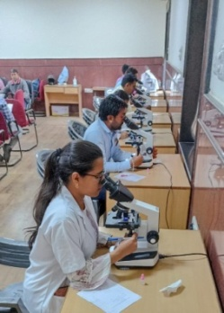
Laboratory Technicians training
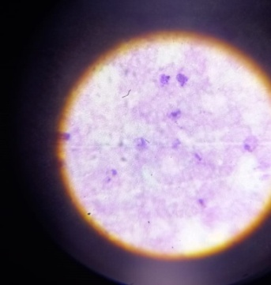
With objective of imparting knowledge about Malaria under NVBDCP, laboratory technicians/Laboratory Assistants are trained at SIHFW in 5 days training. Make shift Laboratory equipped with microscopes is established in a training hall at SIHFW for this type of training. Participants are trained by Nodal Officer, Malaria programme (NVBDCP) and senior Laboratory technicians/ Lab assistants on appropriate sampling and diagnosis of Malaria. This is a hands-on skill development training.

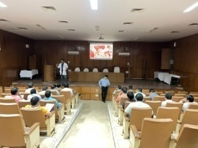
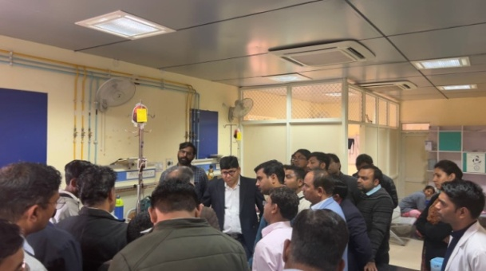
Training on Hemophilia and Hemoglobinopathy
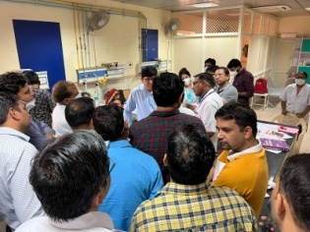
Hands on training on Hemophilia and Hemoglobinopathy was organized by SIHFW at JK Lone Hospital, Jaipur. The training is of 3 days. Participants are oriented on interpretation of CBC, management of haemophilia, Thalassemia and sickle cell diseases, approach to bleeding disorder were main contents of this training. The training also included real life case discussions on Hemophilia/ thalassemia/ hemoglobinopathy. In this training a visit is organized to JK lone for demonstration and hands-on practice. 2 batches were organized during January to March 2023 at SIHFW.

Training workshop on Viral Hepatitis
A 2 days training workshop on Viral Hepatitis was organized under National Viral Hepatitis Program with an objective to orient participants on laboratory diagnostics of various types of Hepatitis (HAV, HBV, HCVand HEV) and to make them capable of effectively delivering quality assured testing services. The training was organised on Feb 27-28, 2023 at SMS Medical College, Jaipur. Training included hands-on sessions on Laboratory Diagnosis of Hepatitis at Microbiology Department SMS hospital.
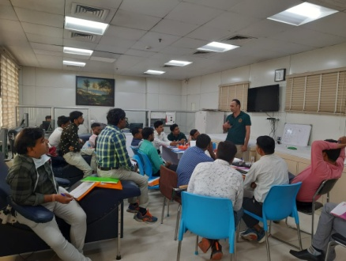
A review meeting of Dy CMHOs was also organized on March 20, 2023 and Pharmacists were trained on Viral Hepatitis on February 3, 2023.
Training of Blood Storage Units
2 days training of Blood storage Units is organised by SIHFW at various state level Hospitals at Jaipur. All 5 planned batches were organised and skills, hands-on sessions are organised at SDMH hospital.

Many other ToTs were also organised at SIHFWE including ToT on New contraceptives-Antara and Chaya - This is a ToT provided to Medical Officers, Nursing Staff and Nursing tutors at SIHFW. This is a 2 days ToT and 1 batch as planned has been organised at SIHFW.
ToT SBA and ToT Dakshata batches were organised at SIHFW and ToT BEmOC batches were organised at Medical College level.

Training of RMNCH/FP Counselors
Family Planning Counselors posted at District Hospitals are trained in this 3 day training at SIHFW on Counseling. The records and progress update of FP counselors is also reviewd and discussed for feedback for improvement. This is 1 day training and 1 batch as planned has been completed at SIHFW.
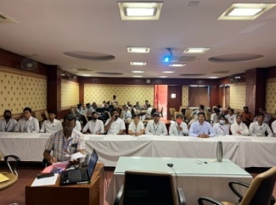
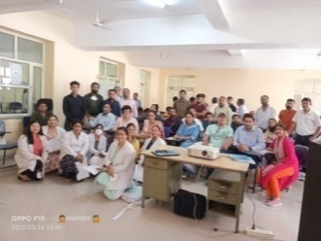
HBNC ToT
ToT on HBNC is organized at SIHFW for 3 days. District level ASHA trainers are trained in this training to become HBNC trainers for ASHA.

Medical Officers Training on Mental Health
Medical Officers are trained on Mental Health at SIHFW in a 5 days training under National Mental Health Program (NMHP). Participants are trained on assessment and management of psychiatric disorders, psychiatric emergencies, Substance use disorder, anxiety spectrum, Neurological disorders, etc. A visit to Psychiatric centre, Jaipur is arranged by SIHFW in every batch for Participants for exposure and case presentation. Participants are also given information on legal, ethical and disability issues in psychiatry. During January to March 2023, 5 batches were organized at SIHFW.
Medical Officers Training on Routine Immunization
This training is organized at SIHFW for Medical Officers on Routine Immunization. This is a 3 day training and each batch starts on Tuesday so that on last day ie.e Thursday participants visit an Immunisation session site at PHC, Sub centre or Anganbari centre for field exposure. 30 batches of these training were organized by SIHFW.
Field Trainings

ToT CAC at Ajmer

One batch of Comprehensive Abortion Care ToT was organized at Medical college and Hospital, Ajmer during March 1-3, 2023 coordinated by SIHFW. Participants from Alwar, Nagaur and Ajmer participated in this training. Participants were Assistant professors, Professors and HOD Gynecology departments.

CAC training 12 days

This is a 12 days training on Comprehensive Abortion Care organized for Medical officers of delivery points. Master trainers trained under ToT CAC are trainers in this training. CAC training batches were organized at various District Hospitals.

Laproscopic Sterilization for Doctors and Refresher

This is a 12 day training provided to Gynecologists and Surgeons. After completing this training, participants are qualified to perform laproscopic sterilization. All 10 batches planned during 2022-23 were completed in the State. Trained participants are provided a refresher training of 3 days after completing 3 years of Laparoscopic Sterilization training.

Minilap Training

Medical officers are provided Minilap training of 12 days in districts, after the training participants are qualified to perform Minilap.

NSV Training

NSV training is of 5 days and it is provided to Medical Officers at district level. This is a skill based training.

SBA training and Refresher

SBA training is provided for 21 days to Nursing staff and Nursing officers for Best labour room practices. This is a skill based training and hands on sessions are organised at District Hospitals. 36 batches planned for this traning have been completed at District Hospitals.

Trained participants are also provided a refresher training of 3 days after completing 3 years of SBA training.

MNDY trainings

This training is organized on Mukhyamantri Nishulk Dava Yojana, it is organized at State level, district level and block level also. This training is coordinated by SIHFW at all levels.

VCCH training

This training is organized for Vaccine Cold Chain Handlers and is organized at SIHFW, 4 batches of 2 days VCCH training were organized at SIHFW.

Routine Immunization

Health workers are trained in 2 day training on Routine Immunization, by SIHFW. This training is organized in all districts for Nursing staff, ANM, LHV and GNM etc.

CHO Induction

Community Health Officers (CHO) are given a 15 days Induction training after joining as CHO. This training is organized in all 34 districts. Participants are oriented on comprehensive primary health care and all major components such as Maternal Health, Child Health, Family Planning, Communicable and Non-communicable disease, Adolescent Health, Telemedicine and Jan Arogya Samiti. CHOs are trained on their role and monitoring indicators for HWC.

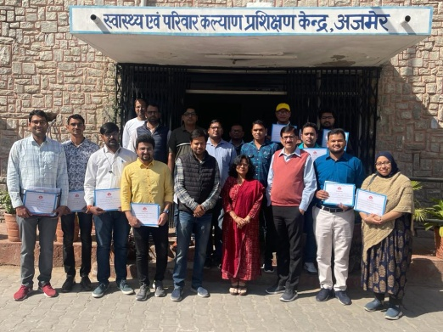
HWC – Extended services in Districts

At present, these training are organized for MOs and CHO working at HWC of all 34 districts of the state. Duration for this trianing is 12 days. Participants are given training on all components under extended services- MNS, Elderly, Palliative, Oral, Eye, ENT and Emergency services. Trainings for MOs are being organized on selected districts – Ajmer-HFWTC, Bikaner, Jodhpur, Rajsamand, Udaipur, Kota Jaipur-I and Jaipur-II. CHOs training on extended services are being organized in all 34 districts.

This training is also provided to HWC ANM (11 days), HWC Staff Nurse (11 days), HWC ASHA (10 days)

Medical Officers 12 days HWC Extended services training at Ajmer-HFWTC.

Ajmer batch Participant Dr Ulma Waquar, HWC-MO, posted at Pisangan block of Ajmer shared a feedback that training is Great!. All contents covered in this training are new to participants, and trainers were all specialists and gave the training with a clinical approach. This knowledge is very useful for MOs.

Picture Gallery of Field trainings
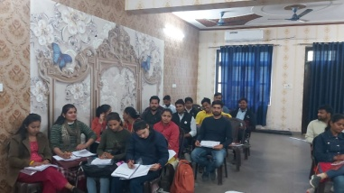
CHO Training at Alwar -February 21 to March 3, 2023
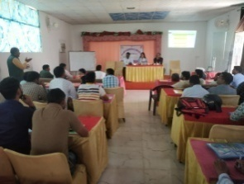

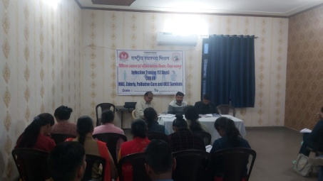
CHO training on extended services (12 days) at Bharatpur -Batch date February 10-21, 2023

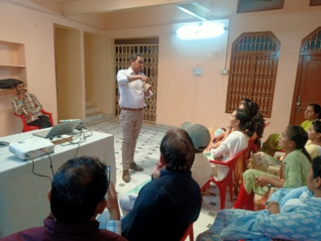

Staff Nurse HWC-Expanded services training batch (11 days) started on 27.2.2023 at Churu

Health News

A woman dies every two minutes due to pregnancy or childbirth: UN agencies
Every two minutes, a woman dies during pregnancy or childbirth, according to the latest estimates released in a report by United Nations. This report, Trends in maternal mortality, reveals alarming setbacks for women’s health over recent years, as maternal deaths either increased or stagnated in nearly all regions of the world.
“While pregnancy should be a time of immense hope and a positive experience for all women, it is tragically still a shockingly dangerous experience for millions around the world who lack access to high quality, respectful health care,” said Dr Tedros Adhanom Ghebreyesus, Director-General of the World Health Organization (WHO). “These new statistics reveal the urgent need to ensure every woman and girl has access to critical health services before, during and after childbirth, and that they can fully exercise their reproductive rights.”
The report, which tracks maternal deaths nationally, regionally and globally from 2000 to 2020, shows there were an estimated 287 000 maternal deaths worldwide in 2020. This marks only a slight decrease from 309 000 in 2016 when the UN’s Sustainable Development Goals (SDGs) came into effect. While the report presents some significant progress in reducing maternal deaths between 2000 and 2015, gains largely stalled, or in some cases even reversed, after this point.
In two of the eight UN regions – Europe and Northern America, and Latin America and the Caribbean – the maternal mortality rate increased from 2016 to 2020, by 17% and 15% respectively. Elsewhere, the rate stagnated. The report notes, however, that progress is possible. For example, two regions – Australia and New Zealand, and Central and Southern Asia – experienced significant declines (by 35% and 16% respectively) in their maternal mortality rates during the same period, as did 31 countries across the world.
“For millions of families, the miracle of childbirth is marred by the tragedy of maternal deaths,” said UNICEF Executive Director Catherine Russell. “No mother should have to fear for her life while bringing a baby into the world, especially when the knowledge and tools to treat common complications exist. Equity in healthcare gives every mother, no matter who they are or where they are, a fair chance at a safe delivery and a healthy future with their family.”
In total numbers, maternal deaths continue to be largely concentrated in the poorest parts of the world and in countries affected by conflict. In 2020, about 70% of all maternal deaths were in sub-Saharan Africa. In nine countries facing severe humanitarian crises, maternal mortality rates were more than double the world average (551 maternal deaths per 100 000 live births, compared to 223 globally).
“This report provides yet another stark reminder of the urgent need to double down on our commitment to women and adolescent health,” said Juan Pablo Uribe, Global Director for Health, Nutrition and Population at the World Bank, and Director of the Global Financing Facility. “With immediate action, more investments in primary health care and stronger, more resilient health systems, we can save lives, improve health and well-being, and advance the rights of and opportunities for women and adolescents.”
Severe bleeding, high blood pressure, pregnancy-related infections, complications from unsafe abortion, and underlying conditions that can be aggravated by pregnancy (such as HIV/AIDS and malaria) are the leading causes of maternal deaths. These are all largely preventable and treatable with access to high-quality and respectful healthcare.
Community-centered primary health care can meet the needs of women, children and adolescents and enable equitable access to critical services such as assisted births and pre- and postnatal care, childhood vaccinations, nutrition and family planning. However, underfunding of primary health care systems, a lack of trained health care workers, and weak supply chains for medical products are threatening progress.
Roughly a third of women do not have even four of a recommended eight antenatal checks or receive essential postnatal care, while some 270 million women lack access to modern family planning methods. Exercising control over their reproductive health – particularly decisions about if and when to have children – is critical to ensure that women can plan and space childbearing and protect their health. Inequities related to income, education, race or ethnicity further increase risks for marginalized pregnant women, who have the least access to essential maternity care but are most likely to experience underlying health problems in pregnancy.
The COVID-19 pandemic may have further held back progress on maternal health. Noting the current data series ends in 2020, more data will be needed to show the true impacts of the pandemic on maternal deaths. However, COVID-19 infections can increase risks during pregnancy, so countries should take action to ensure pregnant women and those planning pregnancies have access to COVID-19 vaccines and effective antenatal care.
"Reducing maternal mortality remains one of the most pressing global health challenges,” said John Wilmoth, Director of the Population Division of the Department of Economic and Social Affairs. “Ending preventable maternal deaths and providing universal access to quality maternal health care require sustained national and international efforts and unwavering commitments, particularly for the most vulnerable populations. It is our collective responsibility to ensure that every mother, everywhere, survives childbirth, so that she and her children can thrive."
The report reveals that the world must significantly accelerate progress to meet global targets for reducing maternal deaths, or else risk the lives of over 1 million more women by 2030.
About the report
The report was produced by WHO on behalf of the United Nations Maternal Mortality Estimation Inter-Agency Group comprising WHO, UNICEF, UNFPA, the World Bank Group and the Population Division of the United Nations Department of Economic and Social Affairs. It uses national data to estimate levels and trends of maternal mortality from 2000-2020. The data in this new publication supersede all previous estimates published by WHO and the United Nations Maternal Mortality Estimation Inter-Agency Group.
About the data
The SDG target for maternal deaths is for a global maternal mortality ratio (MMR) of less than 70 maternal deaths per 100,000 live births by 2030. The global MMR in 2020 was estimated at 223 maternal deaths per 100,000 live births, down from 227 in 2015 and from 339 in 2000. During the Millennium Development Goal era from 2000 to 2015, the global annual rate of reduction was 2.7%, but this fell to negligible levels during the first five years of the SDG era (from 2016 to 2020).
The report includes data disaggregated by the following regions, used for SDG reporting: Central Asia and Southern Asia; Sub-Saharan Africa; Northern America and Europe; Latin America & the Caribbean; Western Asia and Northern Africa; Australia and New Zealand; Eastern Asia and South-eastern Asia, and Oceania excluding Australia and New Zealand. Most recent update in India show improvement of India MMR is 97 and that of Rajasthan is 113 (source: SRS MMR Bulletin, 2018-20)
A maternal death is defined as a death due to complications related to pregnancy or childbirth, occurring when a woman is pregnant, or within six weeks of the end of the pregnancy.
Source: HO Media News/ 23.2.2023/ Geneva/New York/Washigton

We solicit your feedback:
Edited and Mentored by: Dr Sunita Thakan, Faculty
Compiled by: Archana Saxena, RO;
IT support: Mohit Dhonkeriya;

State Institute of Health & Family Welfare
Jhalana Institutional Area, South of Doordarshan Kendra Jaipur (Raj)
Phone-2706496, 2701938, Fax- 2706534
E-mail:-sihfwraj@ymail.com; Website: www.sihfwrajasthan.com

